Questions:

## Classicmodels database

### 1. List all the products of those productlines with more than 10,000 quantity of orders in total, sort by MSRP descending (productline is like a product category).

### Do it in single query.

Answer:

|  |  |  |
| --- | --- | --- |
| S10_1949 | 1952 Alpine Renault 1300 | Classic Cars |
| S12_1108 | 2001 Ferrari Enzo | Classic Cars |
| S12_1099 | 1968 Ford Mustang | Classic Cars |
| S10_4698 | 2003 Harley-Davidson Eagle Drag Bike | Motorcycles |
| S12_3891 | 1969 Ford Falcon | Classic Cars |
| S18_1749 | 1917 Grand Touring Sedan | Vintage Cars |
| S18_3232 | 1992 Ferrari 360 Spider red | Classic Cars |
| S18_2795 | 1928 Mercedes-Benz SSK | Vintage Cars |
| S18_2238 | 1998 Chrysler Plymouth Prowler | Classic Cars |
| S18_1662 | 1980s Black Hawk Helicopter | Planes |

.

.

.

### 2. The company recently realized that all missing information on sales representative employee numbers in customers table (salesRepEmployeeNumber column) are related to an employee with employee number of 1800.

### Select salesRepEmployeeNumber column, fill missing information with correct value.

### Insert new row in employees table about missing employee with below information:

employeeNumber:1800

lastName: Dave

firstName: Ruddy

extension: x98

email: druddy@classicmodelcars.com

officeCode: 7

reportsTo: 1102

jobTitle: Sales Rep

### Update missing value in salesRepEmployeeNumber column of customers table with correct value.

### 3. List all the employees who are managing or supervising at least someone else (list their names, titles and number of employees they are managing).

### Write your query with sub queries and IN

### Write your query with sub queries and EXISTS

### Write your query with JOIN (self join)

Answer:

|  |  |  |  |  |  |  |  |
| --- | --- | --- | --- | --- | --- | --- | --- |
| 1002 | Murphy | Diane | x5800 | dmurphy@classicmodelcars.com | 1 |  | President |
| 1056 | Patterson | Mary | x4611 | mpatterso@classicmodelcars.com | 1 | 1002 | VP Sales |
| 1088 | Patterson | William | x4871 | wpatterson@classicmodelcars.com | 6 | 1056 | Sales Manager (APAC) |
| 1102 | Bondur | Gerard | x5408 | gbondur@classicmodelcars.com | 4 | 1056 | Sale Manager (EMEA) |
| 1143 | Bow | Anthony | x5428 | abow@classicmodelcars.com | 1 | 1056 | Sales Manager (NA) |
| 1621 | Nishi | Mami | x101 | mnishi@classicmodelcars.com | 5 | 1056 | Sales Rep |

## Sakila database

* Creatitng Sakila database: you can find its sql code in portal. Download two files: sakila-schema.sql and sakila-data.sql . First execute sakila-schema and then sakila-data.sql in your sql workbench. Below is the ER diagram and relational schema of this database:

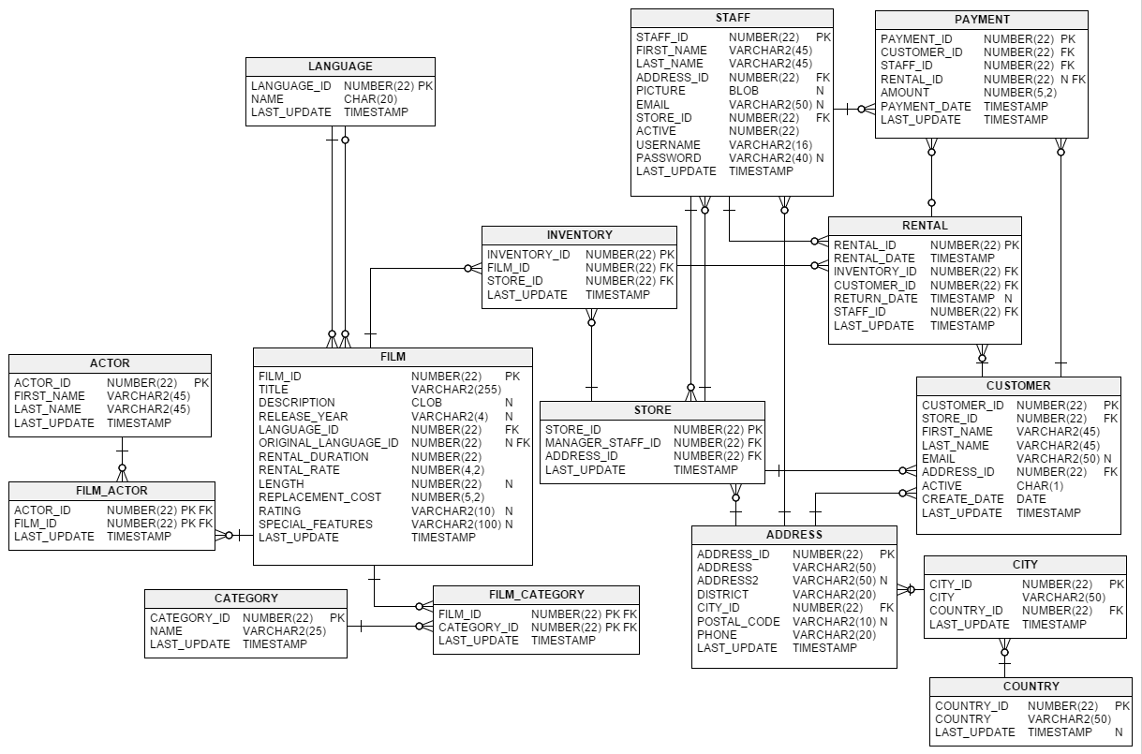

### 4. Find out number of movies of each actor has played. Return the most active and least active actor.

Answer:

|  |  |  |  |  |  |
| --- | --- | --- | --- | --- | --- |
| 107 | GINA | DEGENERES | 2006-02-15 04:34:33 |  | 42 |
| 148 | EMILY | DEE | 2006-02-15 04:34:33 |  | 14 |

### 5. Among active customers, who have rented movies the least frequent in year 2006?

318 1 BRIAN WYMAN BRIAN.WYMAN@sakilacustomer.org 323 1 2006-02-14 22:04:37 2006-02-15 04:57:20 12